1. Write the C# code to display “<n> minute(s) ago" if difference between both dates is less than an hour and “<n> hour(s) ago" if the difference is less than a day and “<n> day(s) ago" if the difference is less than a month and the date if the difference is more than a month.

public class DateTimeToHumanReadableFormFormatter

{

public static string Format(DateTime date, DateTime current)

{

//code here

}

}

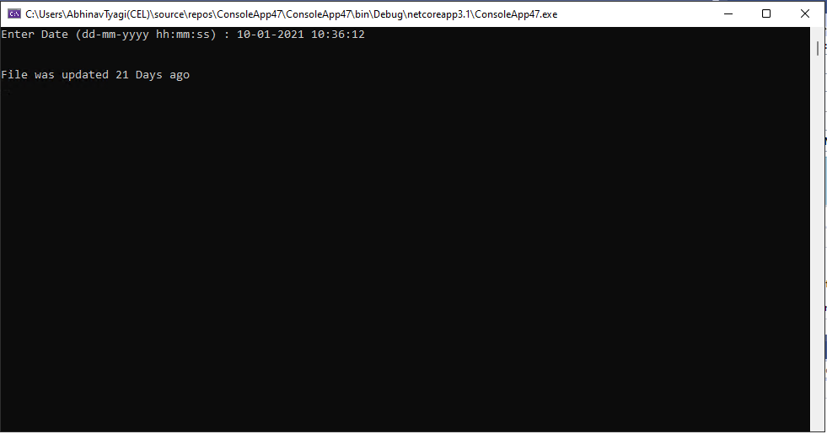

1. Write a program in C# Sharp to create and read last n number of lines of a file. [Go to the editor](https://www.w3resource.com/csharp-exercises/file-handling/index.php#editorr)  
   *Test Data and Expected Output* :

Input number of lines to write in the file :5

Input 5 strings below :

Input line 1 : line1

Input line 2 : line2

Input line 3 : line3

Input line 4 : line4

Input line 5 : line5

Input last how many numbers of lines you want to display :3

The content of the last 3 lines of the file mytest.txt is :

The last no 3 line is : line3

The last no 2 line is : line4

The last no 1 line is : line5

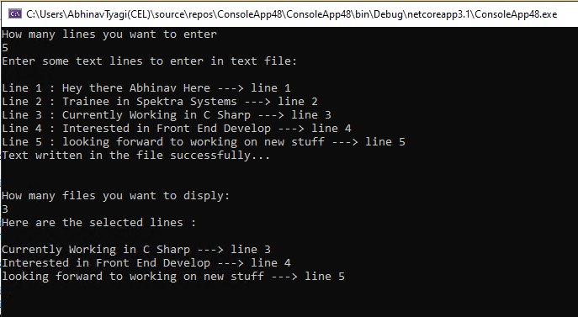

1. Write a function:

class Solution { public int solution(int[] A); }

that, given an array A of N integers, returns the smallest positive integer (greater than 0) that does not occur in A.

For example, given A = [1, 3, 6, 4, 1, 2], the function should return 5.

Given A = [1, 2, 3], the function should return 4.

Given A = [−1, −3], the function should return 1.

Assume that:

N is an integer within the range [1..100,000]; each element of array A is an integer within the range [−1,000,000..1,000,000]. Complexity:

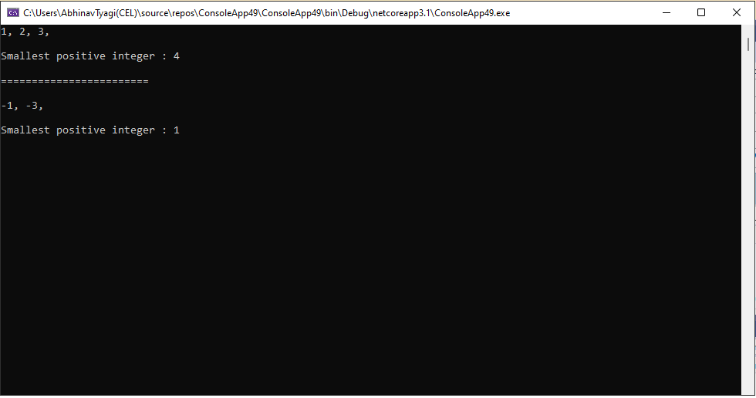

1. Given six digits, find the earliest valid time that can be displayed on a digital clock (in 24-hour format) using those digits.

For example, given digits 1, 8, 3, 2, 6, 4 the earliest valid time is "12:36:48". Note that "12 : 34 : 68" is not a valid time.

Write a method:

class Solution { public String solution(int A, int B, int C, int D, int E, int F); }

That, given six integers A, B, C, D, E and F, returns the earliest valid time in "hh:mm:ss" string format, or "NOT POSSIBLE" if it is not possible to display a valid time using all six integers.

For example, given 1, 8, 3, 2, 6, 4 the function should return "12:36:48".

Given 0, 0, 0, 0, 0, 0, the function should return "00:00:00". Given 0, 0, 0, 7, 8, 9, the function should return "07:08:09". Given 2, 4, 5, 9, 5, 9, the function should return "NOT POSSIBLE".

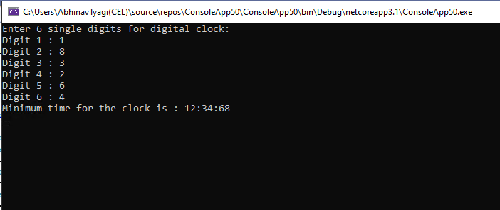

Assume that: • A, B, C, D, E and F are integers within the range [0..9].

1. Reverse the ordering of words in a String

I have this string

s1 = "My name is X Y Z"

and I want to reverse the order of the words so that

s1 = "Z Y X is name My"

